**Mini Bug Report**

**Bug 1 – UX Bug: Missing Direct "My Brands" Button**

* **Bug ID:** BUG-UX-001
* **Severity:** Medium
* **Priority:** High
* **Module:** Daily Earn → Navigation to My Brands
* **Steps to Reproduce:**
  1. Complete a Daily Earn action for any brand.
  2. Try to locate **My Brands**.
  3. Observe that no **direct “My Brands” button** exists on the Daily Earn page.
* **Expected Result:**  
  A **My Brands button** should be visible on the Daily Earn page, allowing direct access.
* **Actual Result:**  
  Users are forced to navigate through **My DataHub** and manually search for the brand.
* **Impact:**
  1. Reduces usability and discoverability.
  2. Increases user frustration, especially for new users.
  3. Inconsistent with common app navigation practices.

**ScreenShot**

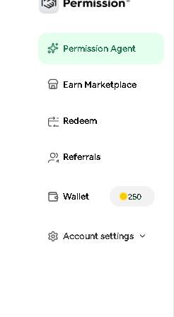

### ****Bug 2 – UX Bug: No Timestamp in Chatbox****

* **Bug ID:** BUG-UX-002
* **Severity:** Low
* **Priority:** Medium
* **Module:** AI Agent → Chatbox
* **Steps to Reproduce:**
  1. Navigate to https://ask.permission.io/ai.
  2. Start a conversation with the AI Agent.
  3. Observe the chat messages.
* **Expected Result:**  
  Each chat message should display a **timestamp** (e.g., “10:32 AM”) for clarity and tracking.
* **Actual Result:**  
  Messages appear with **no timestamp**; only text bubbles are shown.
* **Impact:**
  1. Users cannot track when a message was sent/received.
  2. Confusing in long sessions where multiple messages are exchanged.
  3. Reduces overall usability and professionalism of the chat interface.

**ScreenShots**

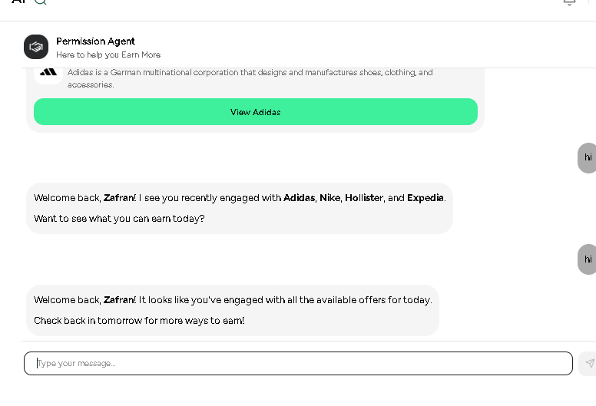

### ****Bug 3 – UX Bug: No Scroll Bar on Small Screens During Registration****

* **Bug ID:** BUG-UX-003
* **Severity:** High
* **Priority:** High
* **Module:** Registration → User Information Form
* **Steps to Reproduce:**
  1. Navigate to the registration page on a **small screen (e.g., 13-inch or smaller)**.
  2. Fill in the registration information until the page extends beyond the visible screen area.
  3. Try to scroll to see all input fields.
* **Expected Result:**  
  A **scroll bar** (vertical) should appear, allowing users to access all fields and buttons.
* **Actual Result:**  
  No scroll bar is displayed; lower fields (e.g., Submit button) become **inaccessible**.
* **Impact:**
  1. Users on small screens **cannot complete registration**.
  2. Blocks new user onboarding.
  3. High severity since it directly affects conversion and accessibility.

**ScreenShots**

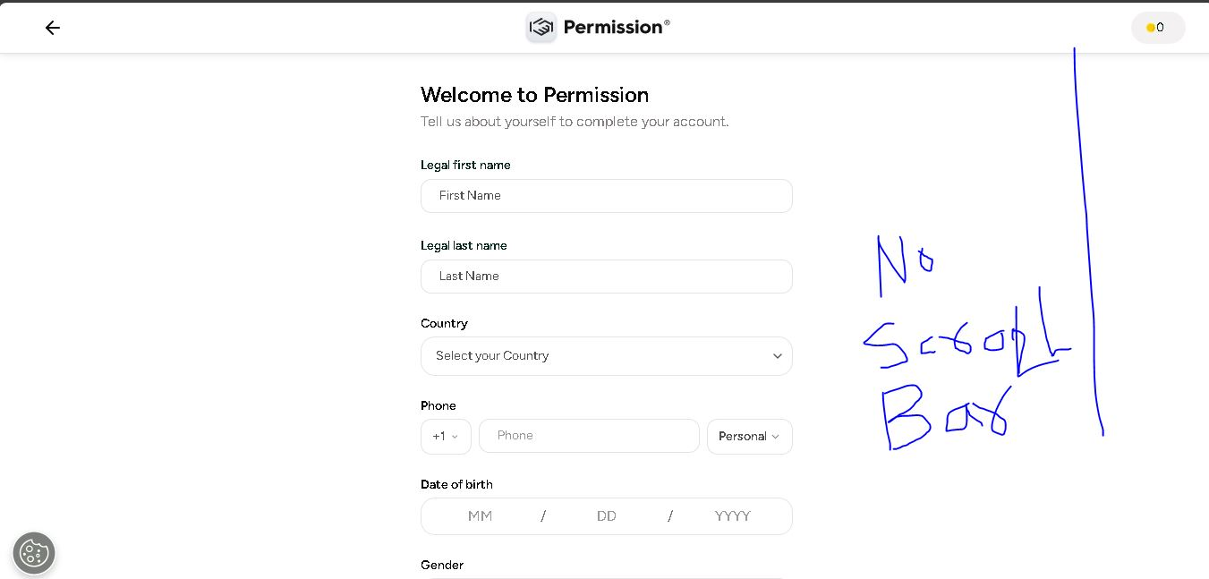

### ****Bug 4 – UI/UX Bug: Unresponsive Footer on Small Screens****

* **Bug ID:** BUG-UX-004
* **Severity:** Medium
* **Priority:** Medium
* **Module:** Website Footer → Responsiveness
* **Steps to Reproduce:**
  1. Open <https://ask.permission.io> on a **mobile device or resize the browser to a small screen (≤ 768px width)**.
* **Expected Result:**  
  The footer should be **responsive**, properly aligned
* **Actual Result:**  
  On smaller screens, the footer appears **unresponsive/misaligned**
* **Impact:**
  1. Hurts usability and accessibility.

**ScreenShots**

